CFARG Weekly Report – Dennis & Barry

Date: Friday, 08 December 2023

# What I did this week

* Analysing the lung function features
  + We considered the 6 parameters (VDP, MSV, TV, VH, VHSS, VHLS) from the PDF reports, and created the 3D correlation graph, Principal Component Analysis (PCA), and basic classifiers.

🡪 We found 3 features (VDP, MSV, VH) are relatively significant, which perform better in 3D correlation graph and PCA, as shown in the interesting results section.

* Analysing the histograms
  + We examined the histograms, and calculated the Heterogenous Disease (HD) value for each histogram.

🡪 We will have further investigations on HD values.

* 3D visualization
  + We created a 3D visualization of the lungs from the specific ventilation csv files.

🡪 This might help the doctors to visualise the lungs, and locate the affected region easier.

# My administrative tasks

* + N/A

# Paper writing

* + N/A

# Things For Next Week

* Analysing histograms:
  + Extract more metrics from the histograms:
    - Mean, Median, Mode, Skewness, Kurtosis (Shape)
    - Quartiles, Interquartile Range, Variance and Standard Deviation (Spread)
    - Signal to Noise Ratio, Entropy (Randomness)
  + Try out some novel ideas like vectorization to analyse the data.

# Future Plans

* Analysing 3D data:
  + Use Auto-encoder, features extraction, dimension reduction, etc. to find interesting results.
  + Use techniques for the time-series data (from Sheep Asthma Study).
* 3D visualization:
  + Create more diverse options to help doctors with the graphs (need more insights from doctors).

# Issues Limiting My Activity

* Limited dataset

# Laboratory issues

* N/A

# Interesting results

3 Features Correlation Graph: Separation of clusters can be observed in ¾ studies: Mouse MPS, Rat Sterile Bead, and Mouse B-ENaC study. The result of Rat PA Study might be affected by other factors like weight, sex, age, etc.

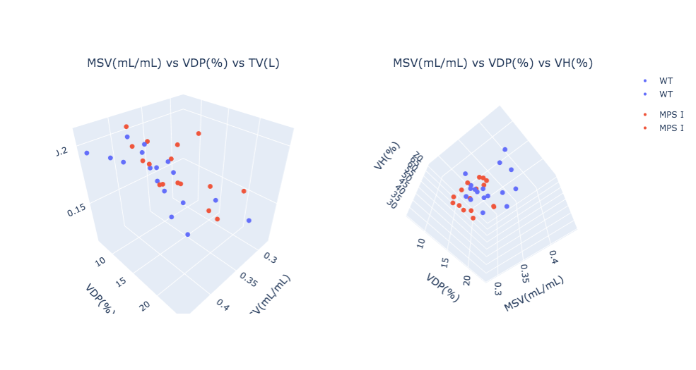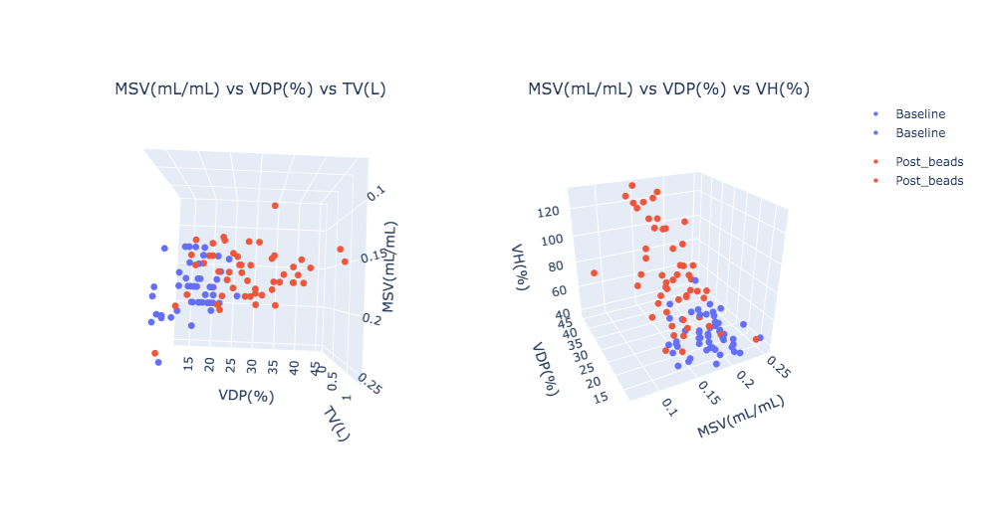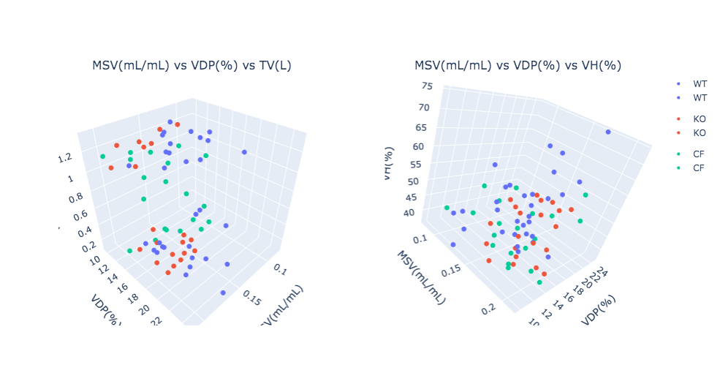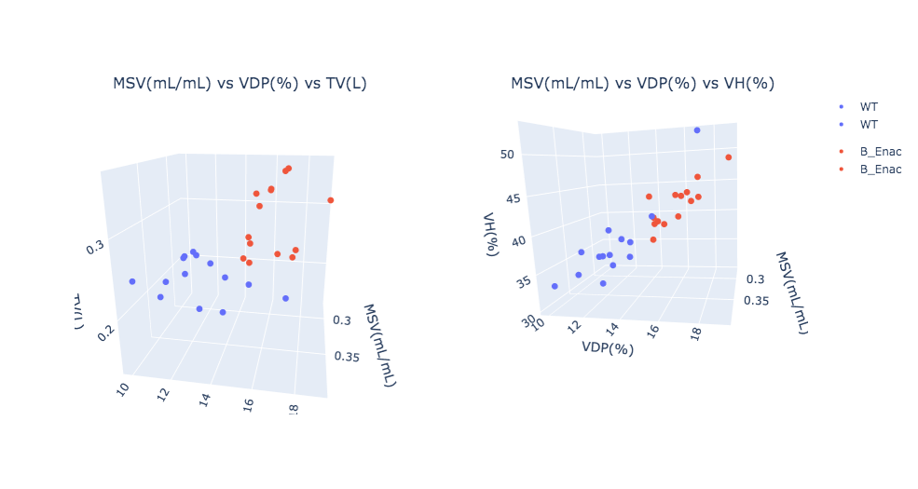

Rat PA Study

Mouse B-ENaC Study

Rat Sterile Bead Study

Mouse MPS Study

3D Principal Component Analysis (PCA): 6 features were used for PCA and we extract PC1, PC2 and PC3. Similar results can be observed.

